**PROJECT DEVELOPMENT PHASE**

**SPRINT – 1**

|  |  |
| --- | --- |
| Date |  |
| Team ID | PNT2022TMID30139 |
| Project Name | A NOVEL METHOD FOR HANDWRITTEN DIGIT RECOGNITION SYSTEM |
| Maximum Marks |  |

**Home.html:**

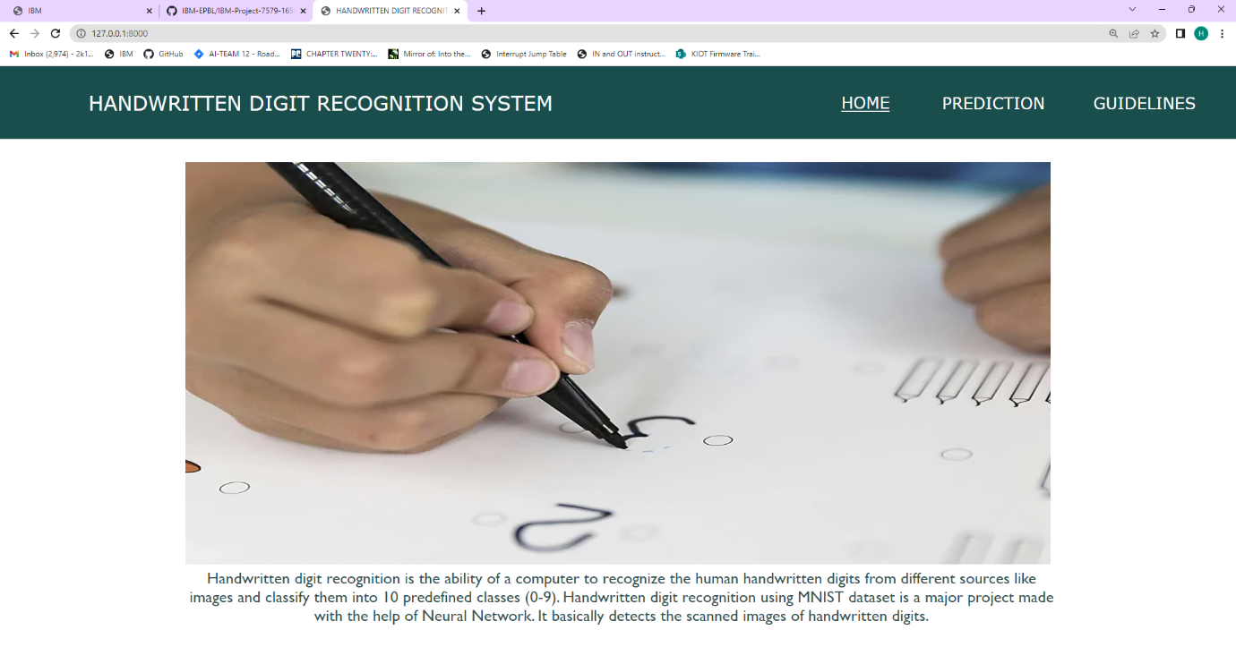

**PREDICTION:**

**Upload.html:**

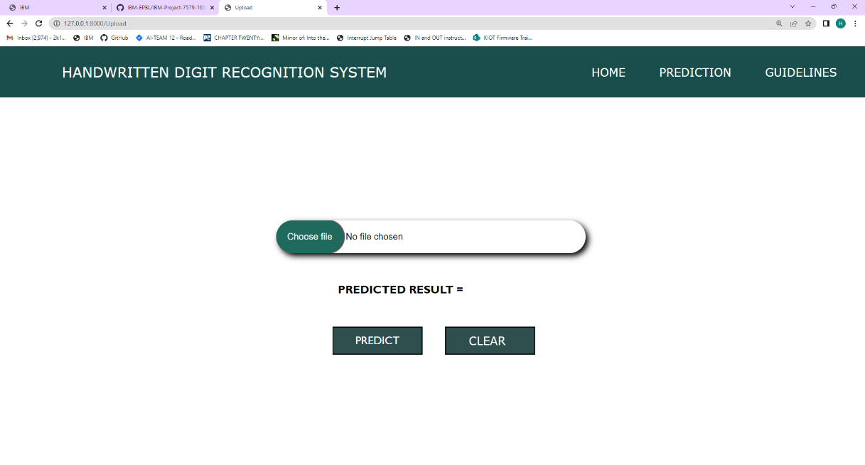

**PREDICTION:  
Draw.html:**

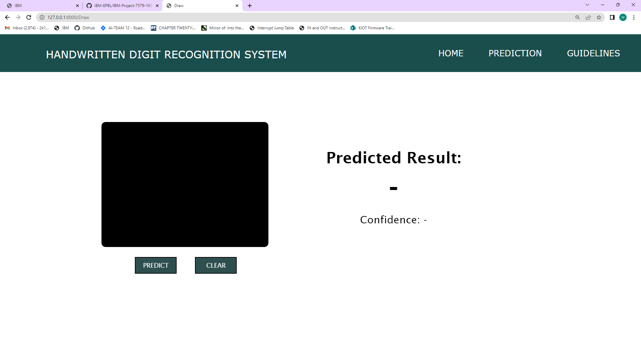

**Guidelines.html:**

